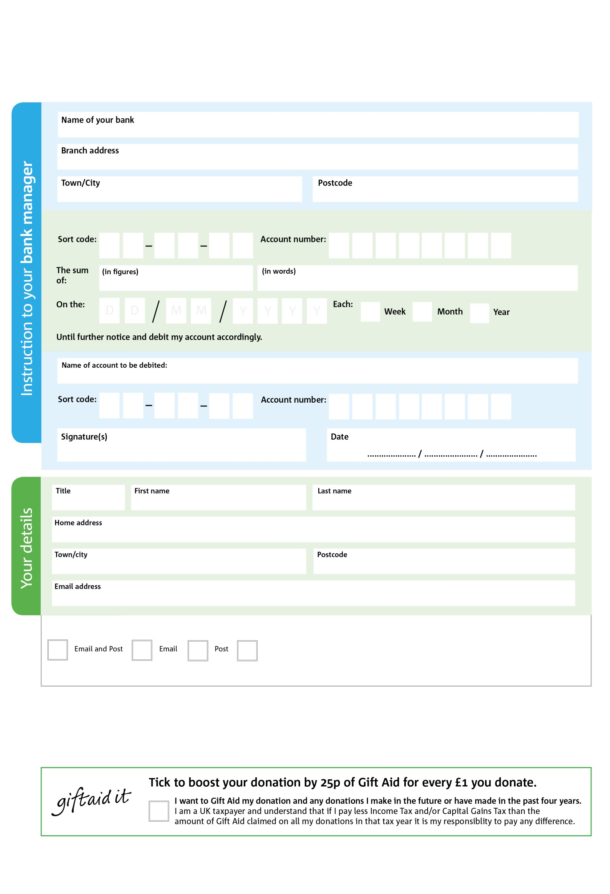

Please pay Fallowfield and Withington Foodbank,

Reg. Charity No: 1173202 | Reg. in England & Wales

**Standing Order Mandate**

**Fallowfieldwithington.foodbank.org.uk**

POSTAL ADDRESSFallowfield and Withington Foodbank, c/o Union Chapel, 2b Wellington Road, Fallowfield, Manchester, M14 6EQ

7

V

9

V

0

V

1

V

4

V

8

V

5

V

6

V

**Please pass this form onto the foodbank, using the foodbank’s address at the bottom, who will save a copy for their records.   
They will then send it onto your named bank or building society.**

9

9

2

9

8

0

We would love to keep you up to date with information about Fallowfield and Withington Foodbank. Please tick your preference:

You can change your preferences any time by contacting us on 07411 077654 or emailing us at info@fallowfieldwithington.foodbank.org.uk

I do not wish to receive future communications from Fallowfield and Withington Foodbank

**Data protection**

*' Fallowfield and Withington Foodbank is committed to protecting your privacy and will process your personal data in accordance with current Data Protection legislation. Fallowfield and Withington Foodbank collects information to keep in touch with you and supply you with information relating to our work. To unsubscribe from our newsletter, send a message to the email address above with the word unsubscribe in the subject line. A full data privacy statement for financial donors is available from the foodbank on request.’*

You can change your preferences any time by contacting us on XXXXXXXXXXX or emailing us at XXXX@XXXXXXXXXX.foodbank.org.uk

I do not wish to receive future communications from XXXXXX Foodbank